**Cloud Q1:**

**EC2:**

1. Search EC2 on AWS :

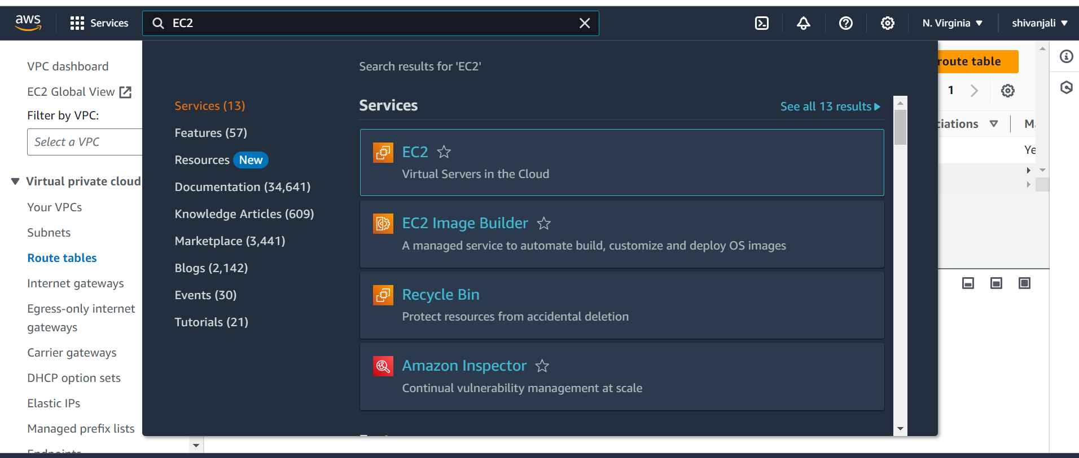

1. Click on EC2

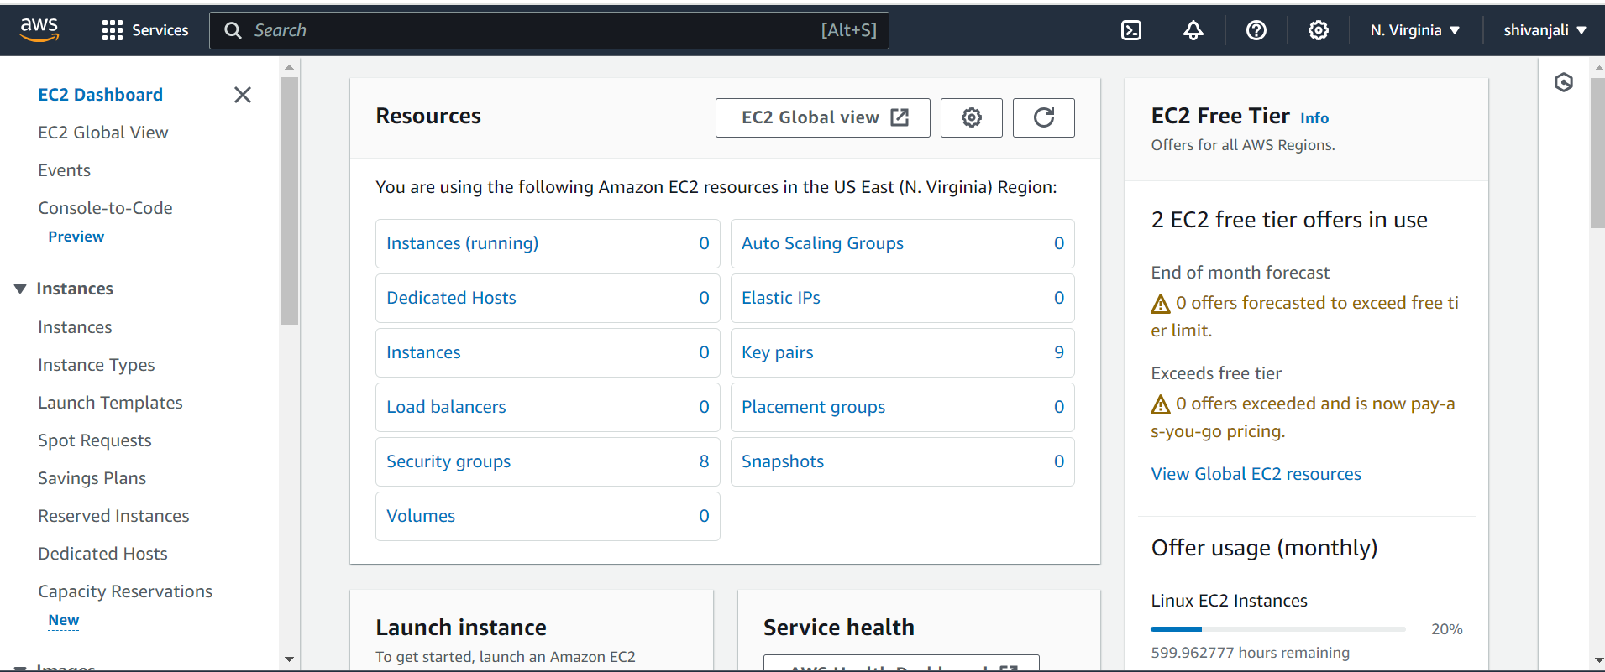

3.click on instance:

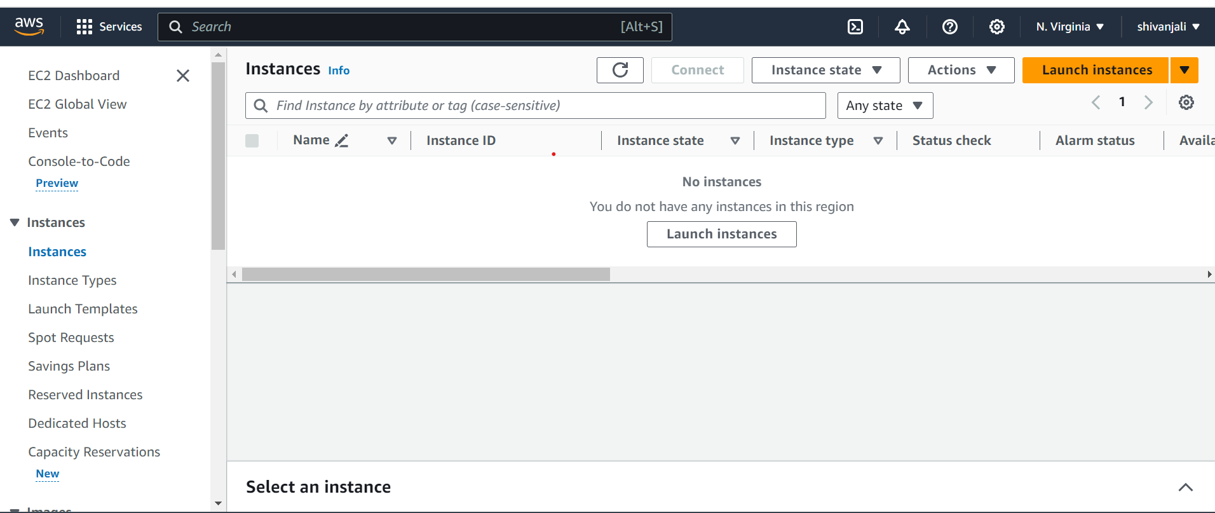

4.Click on Launch instances and give name :

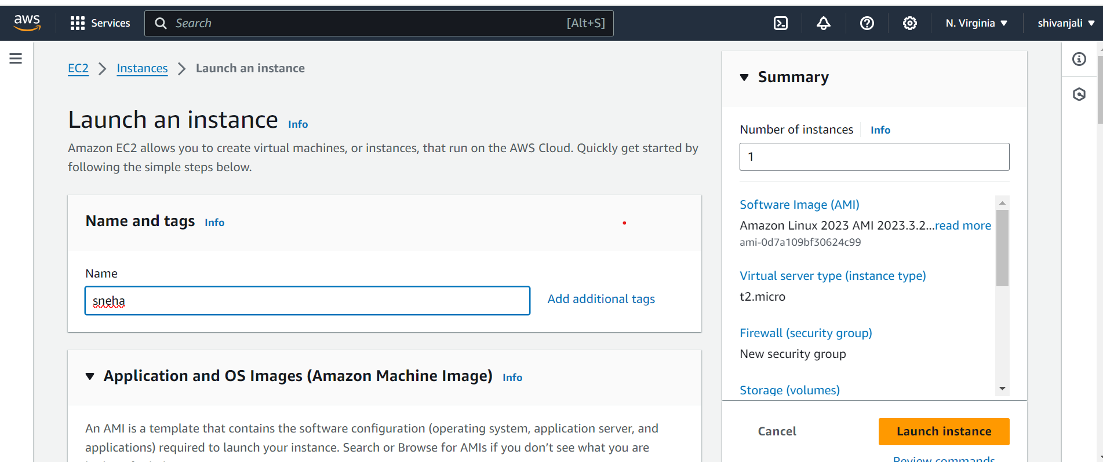

5. check Amazon Machine Image :on that we select Amazon Linux aws 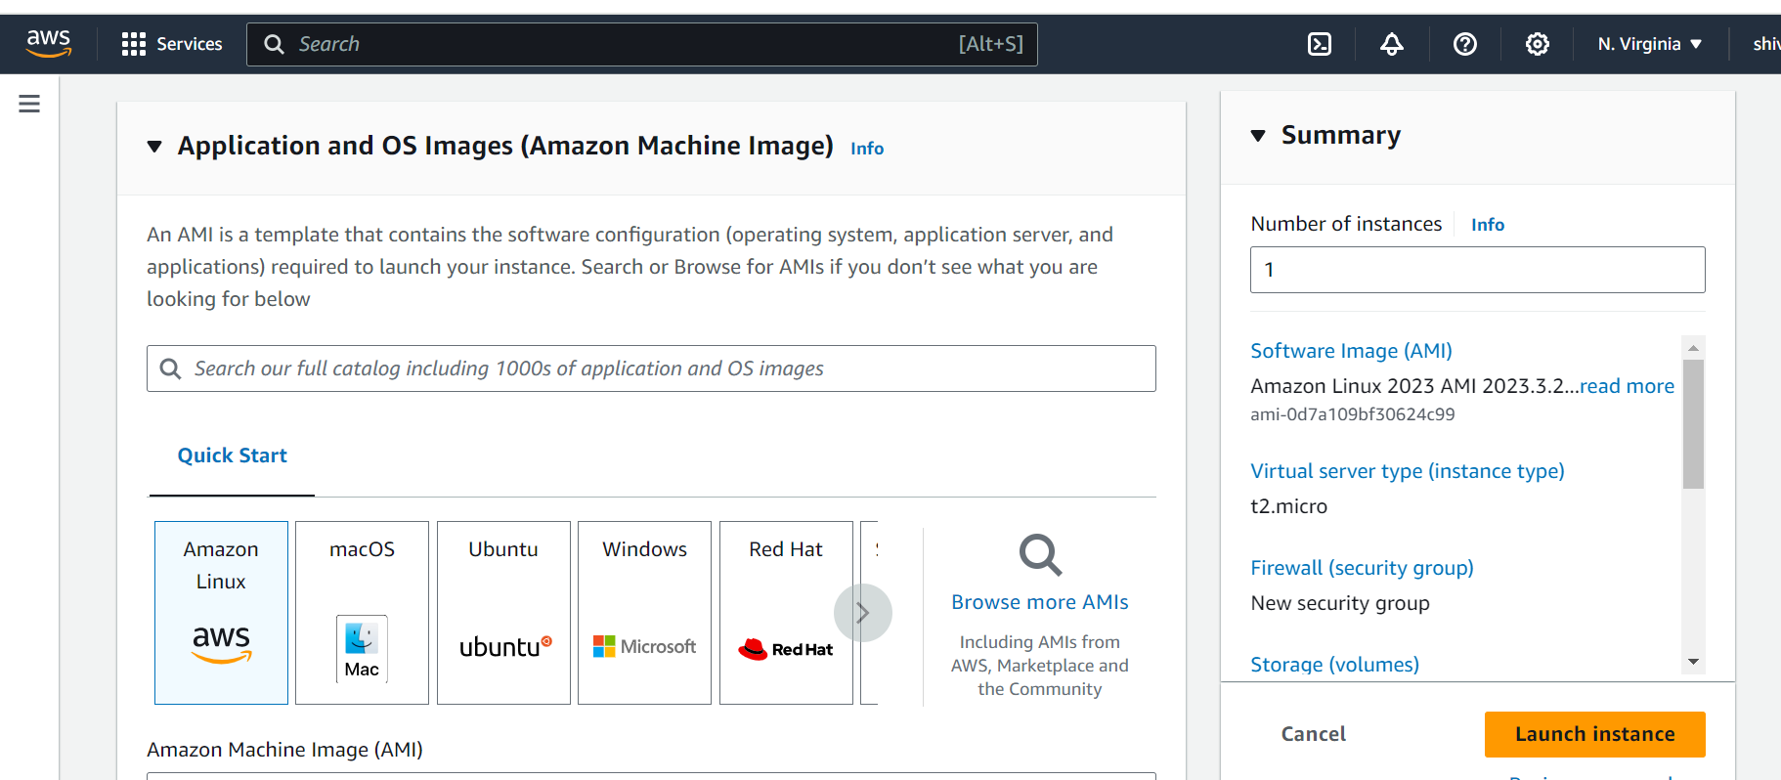

6. Check instance type:

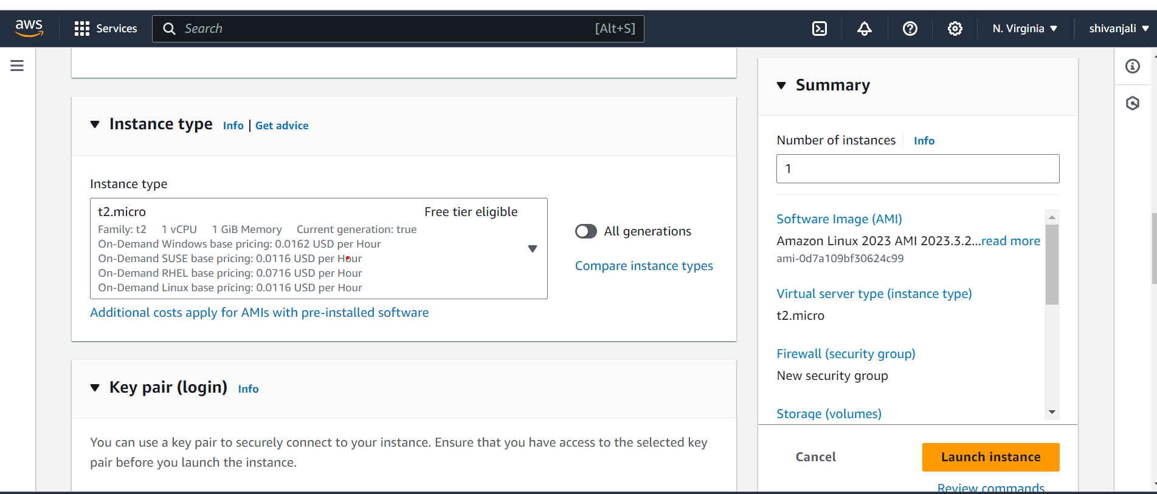

7. Go to key pair and click on create new key pair and give a name for that key :

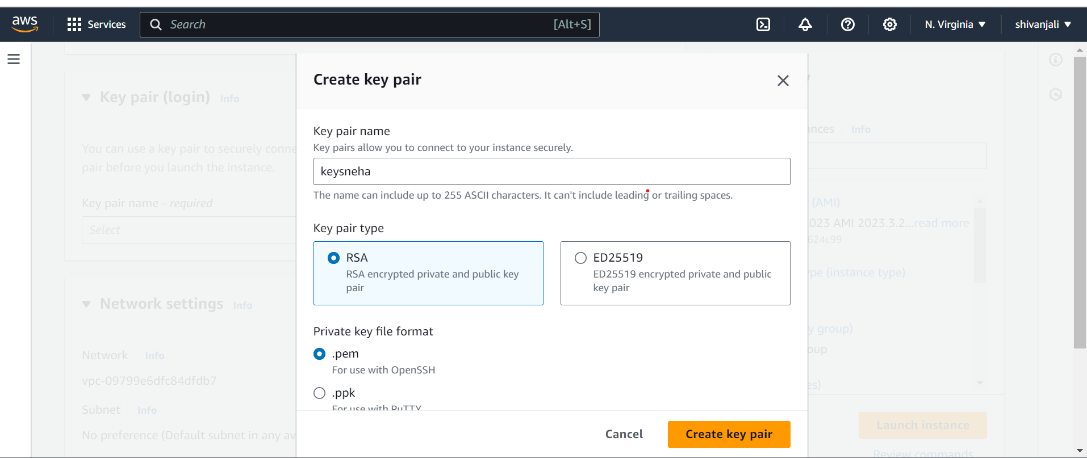

8.select .ppk file format:

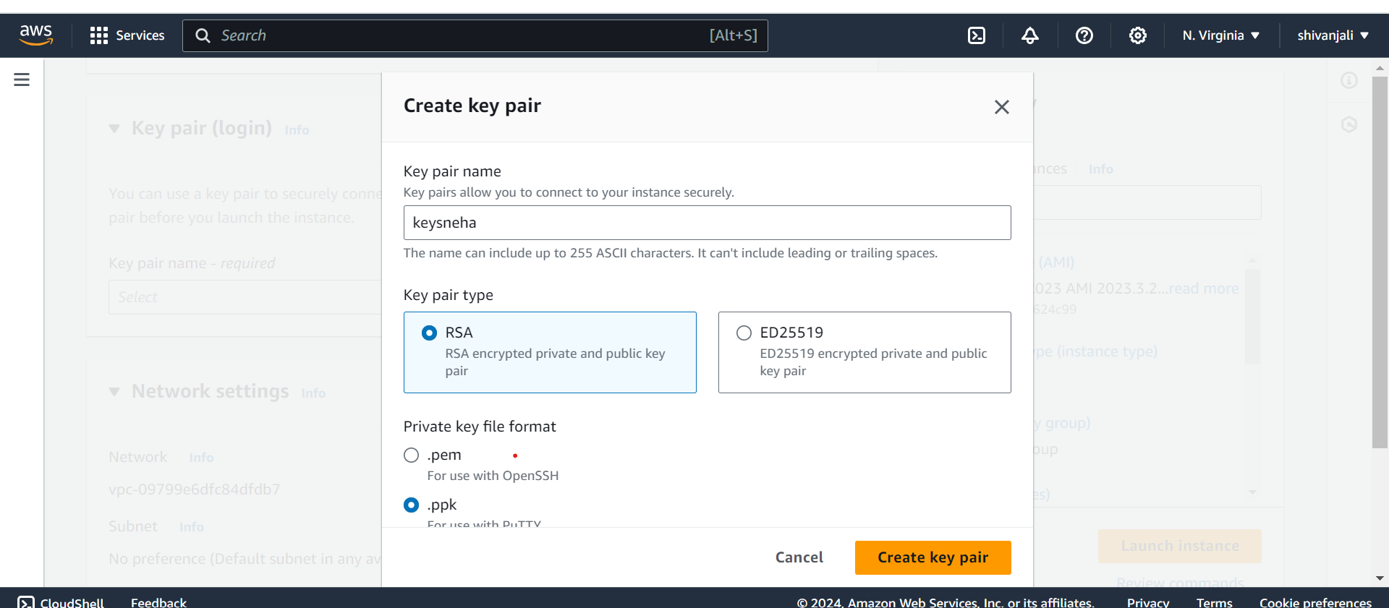

9.Click to create key pair

10.After click on create key pair then its download

11.Allow for all:

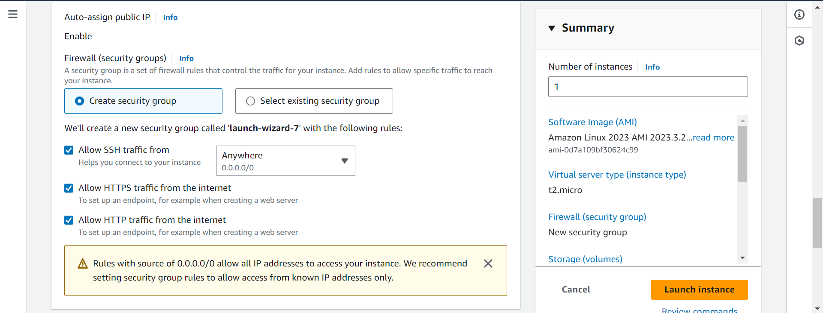

12.Then click on launch instance:



13.After launch instance then the successfully window is display:

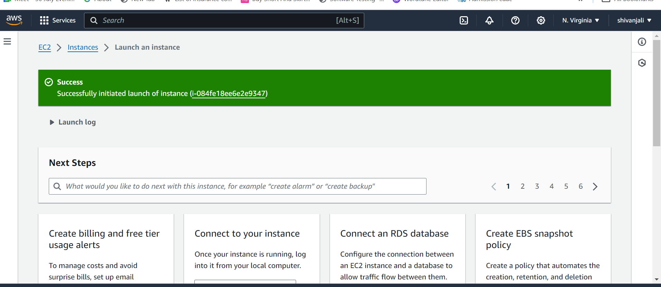

14. open the instance:

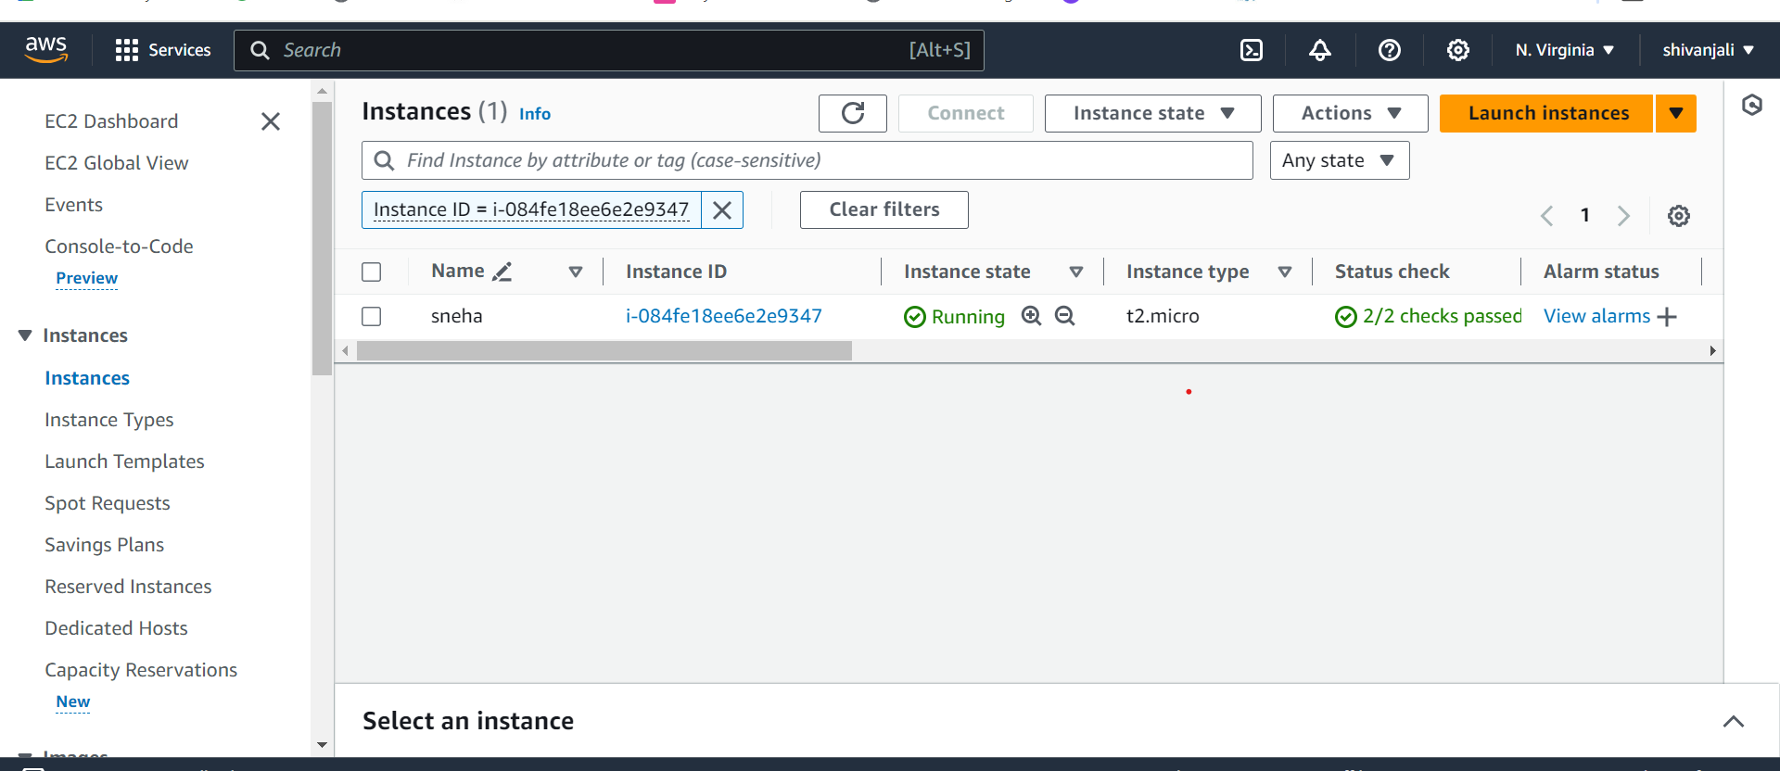

15. Click on instance and copy the ip address:

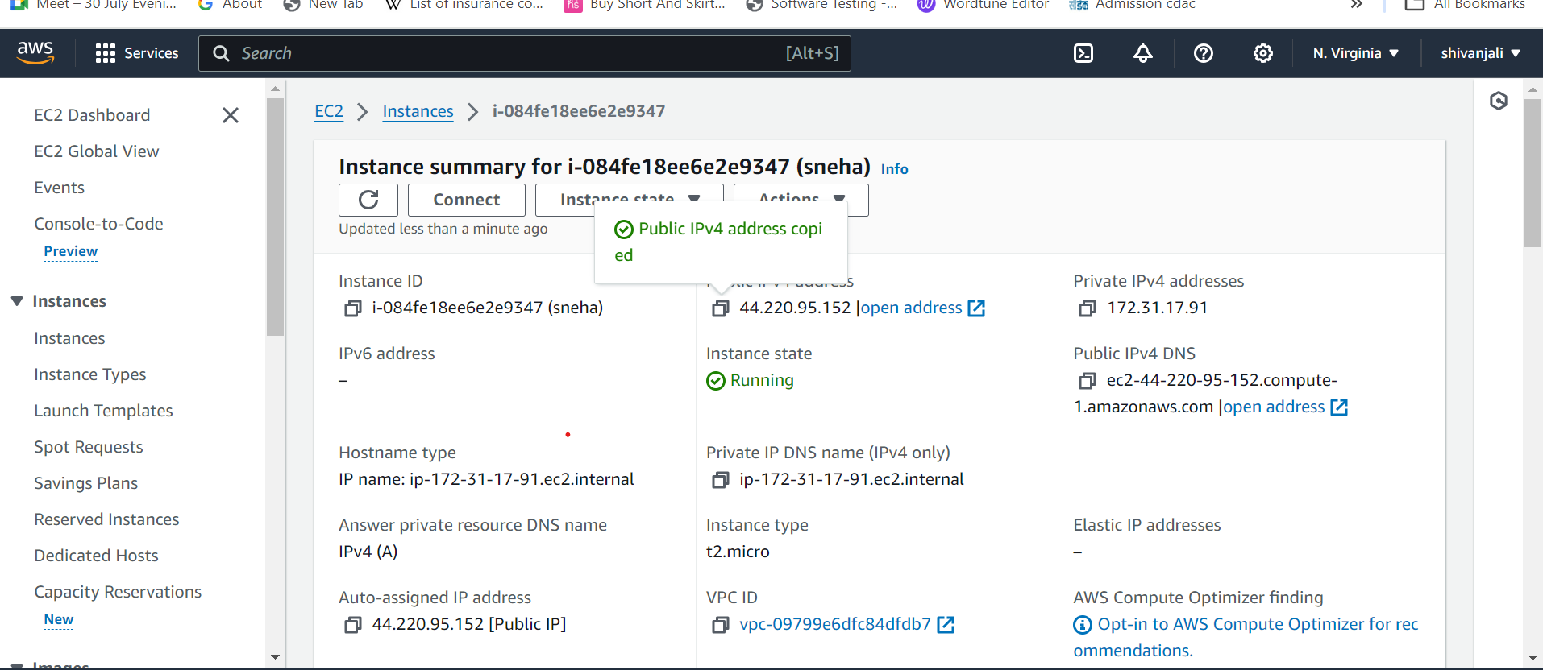

16.Search putty on the terminal

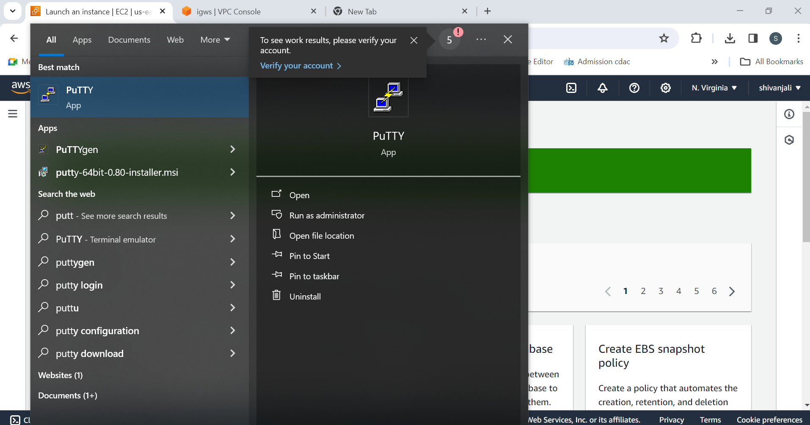

15. click on that

16 .putty configuration window is display

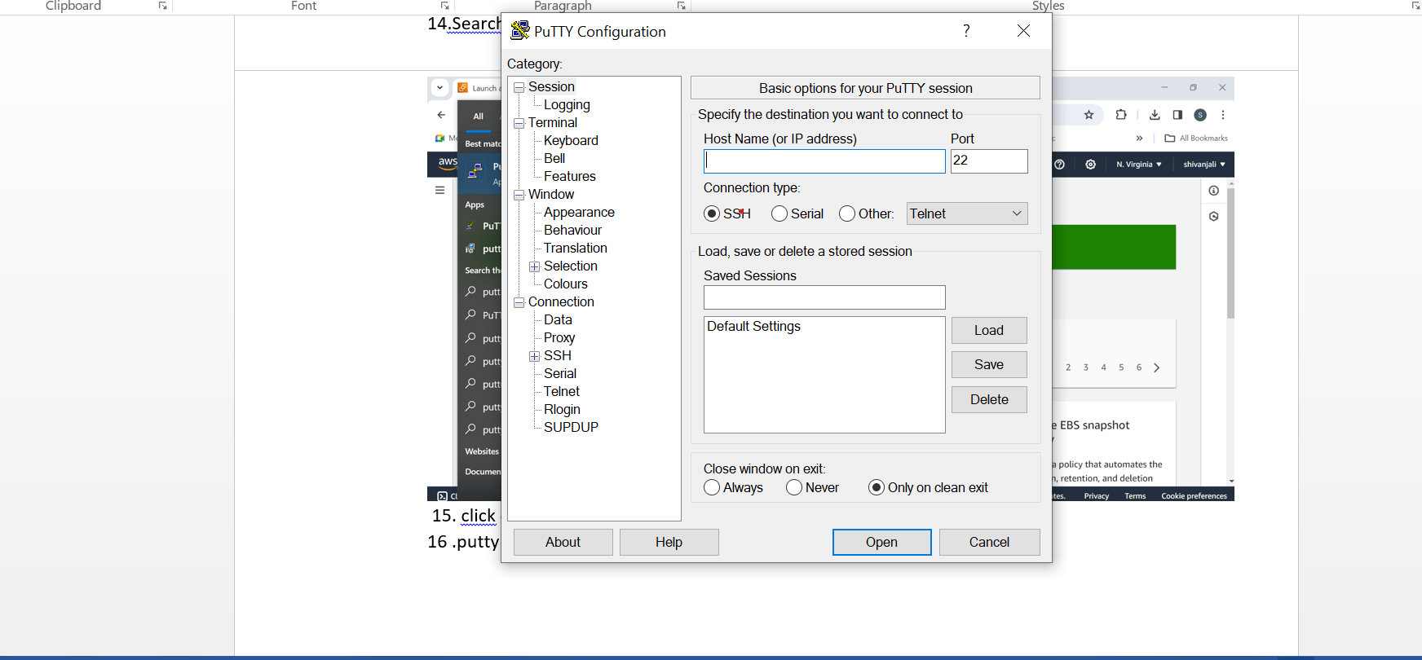

17.enter the ip address

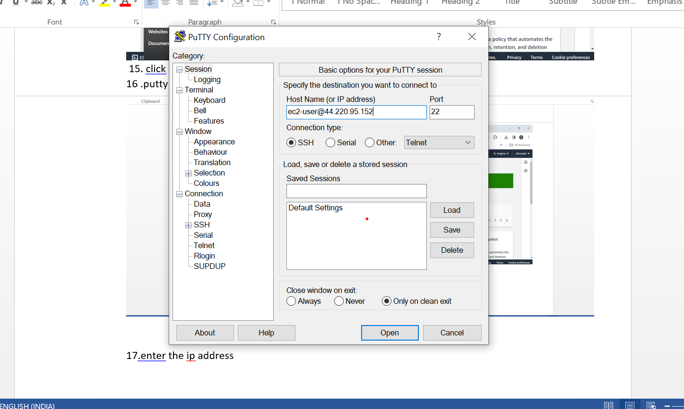

18. Go to SSH on left side:

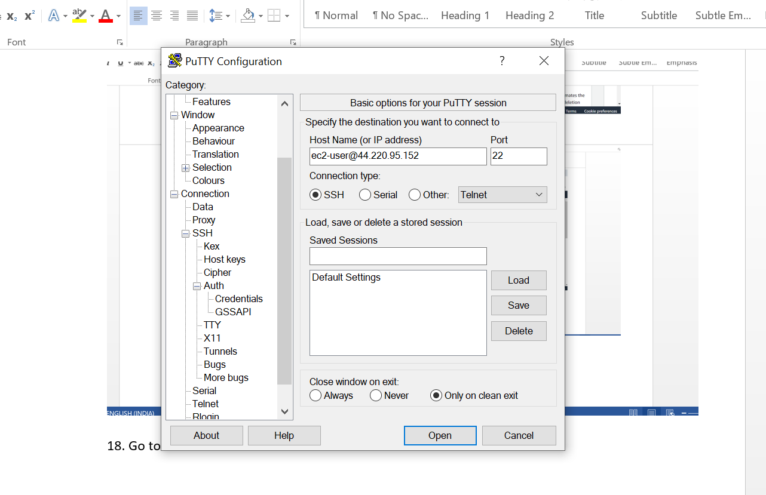

19. Click on auth and then click on credentials:

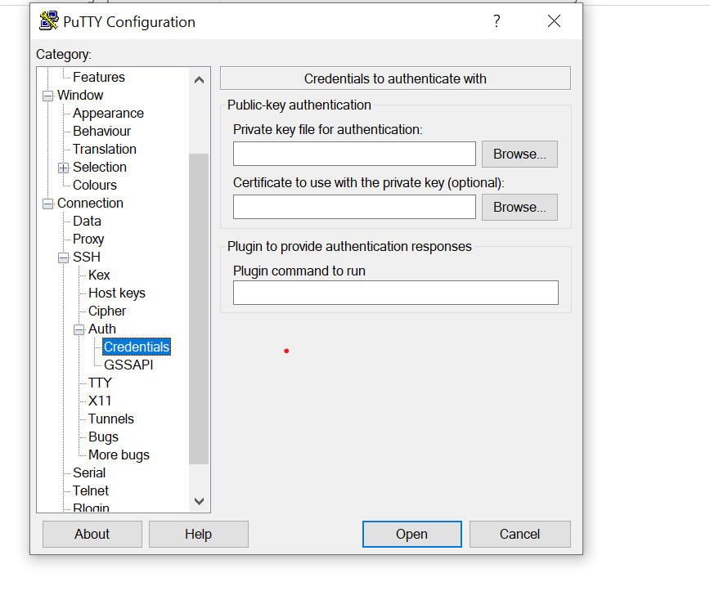

20.Browse the key pair file:

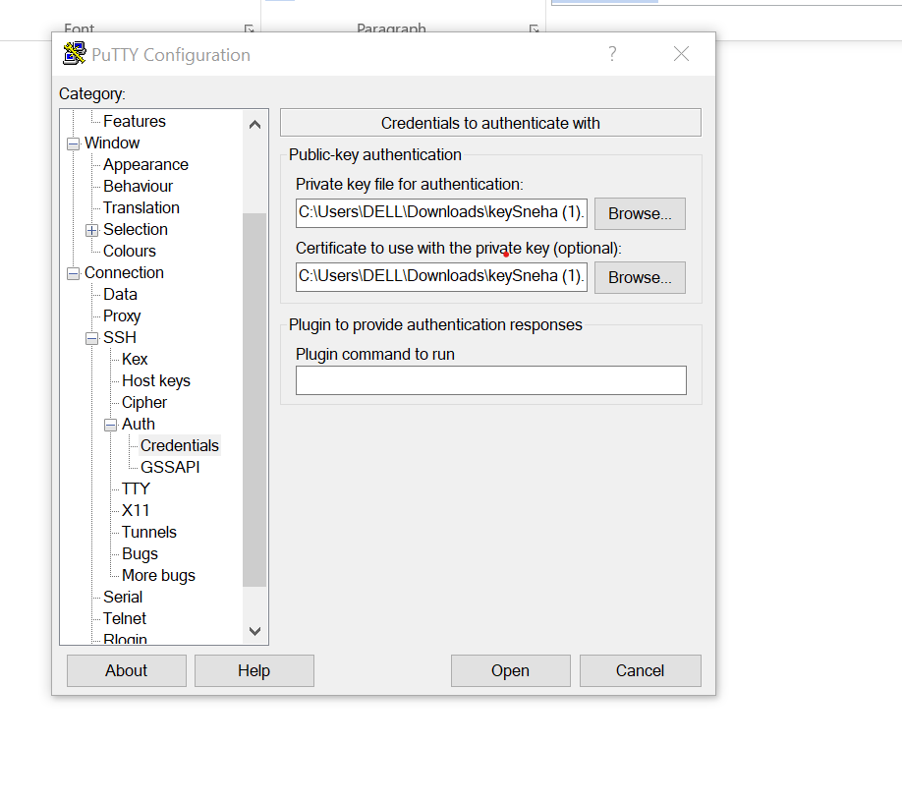

21.click on open:

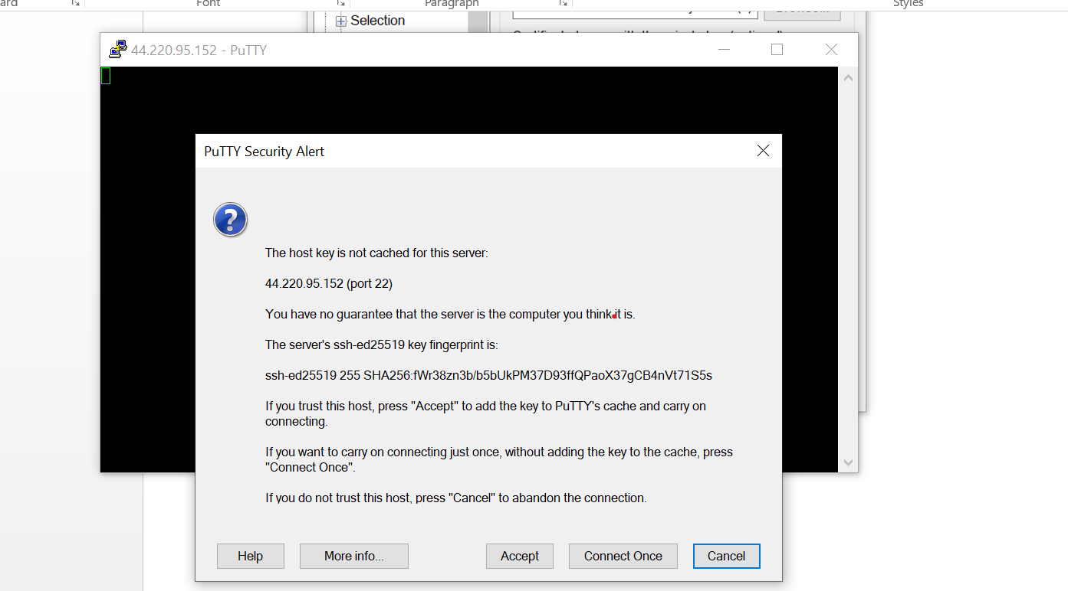

22. click on Accept

23.After click on accept then the putty terminal window is open:

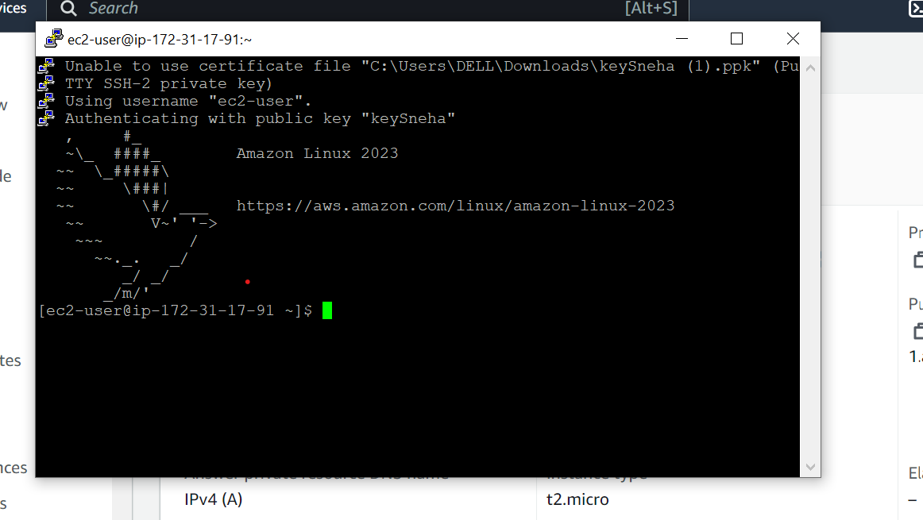

24:

Write the commands on that :

1. Sudo –i
2. yum update –y: in this command yum use to package and –y means yesi want to update the package
3. yum install httpd –y:This command is used to install the package
4. systemctl start httpd:this command is used to start the http server
5. systemctl status httpd :this command is used to check the status of http server
6. systemctl enable httpd : this command is used to check the http server is enable or not
7. cd /var/www/html : this command is used to go html page
8. vi new.html : it is used to enter a data on that file

24: yum update –y:

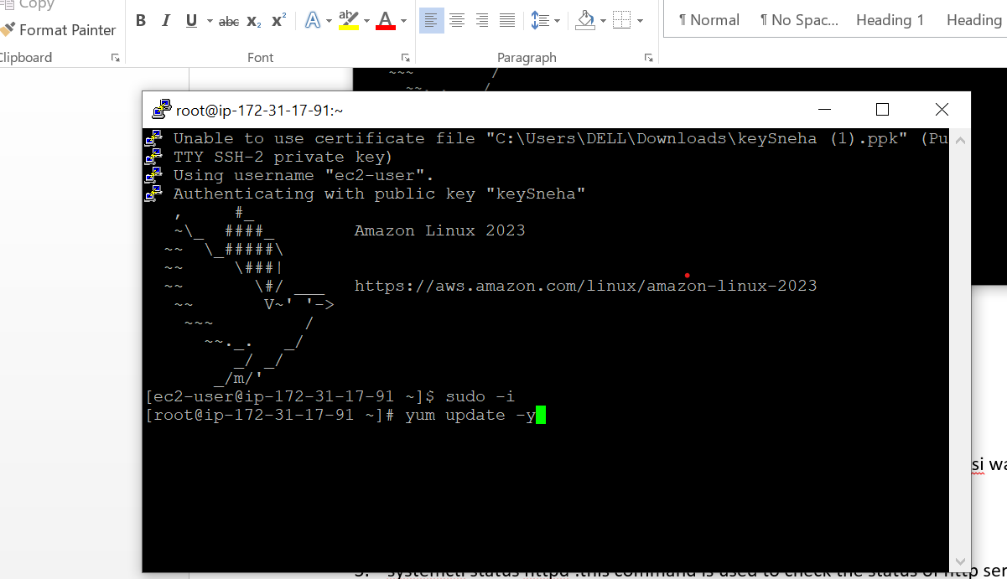

25. yum install httpd –y:

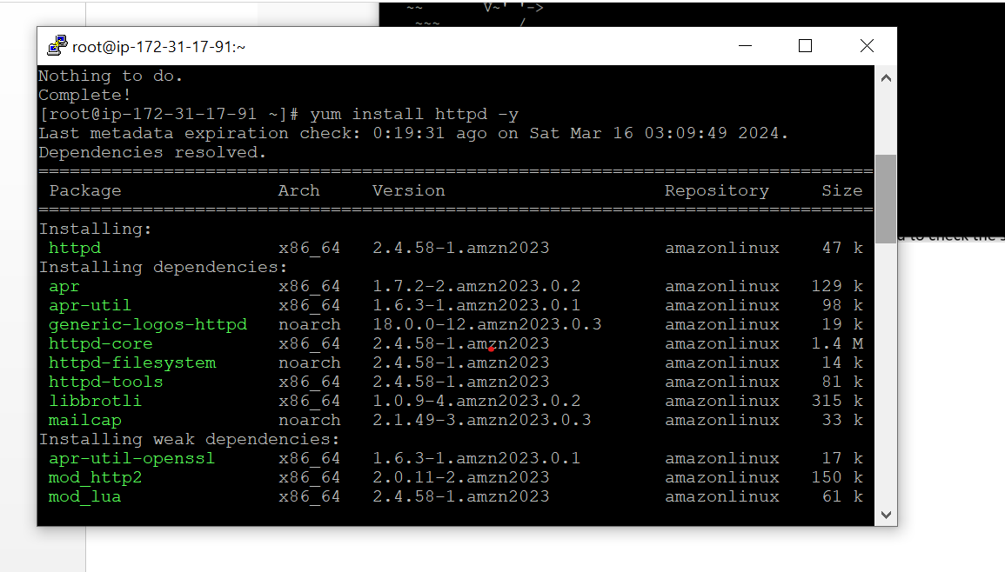

26. systemctl start httpd:

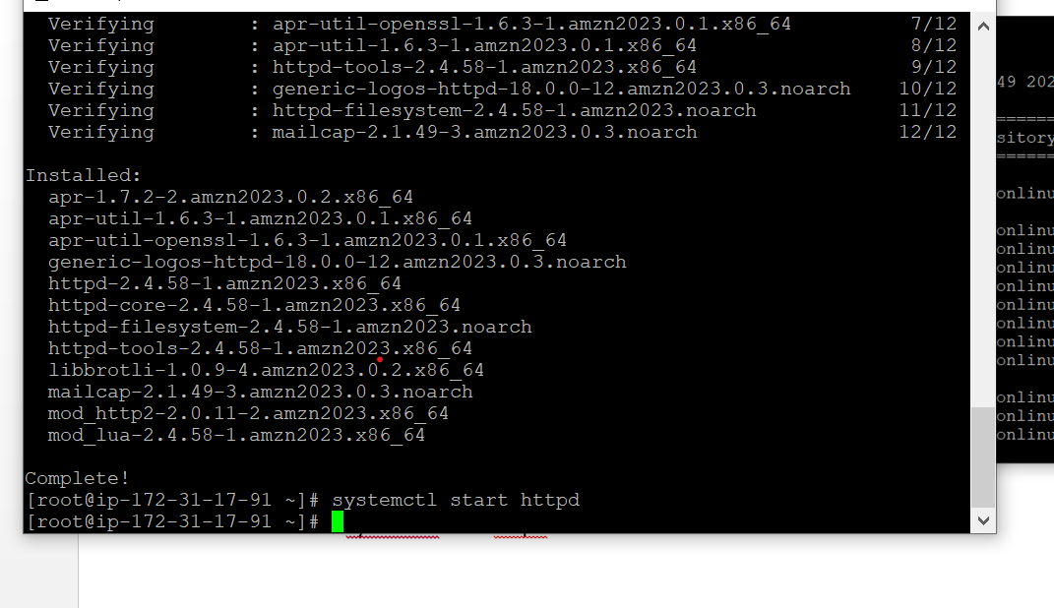

27. systemctl status httpd :

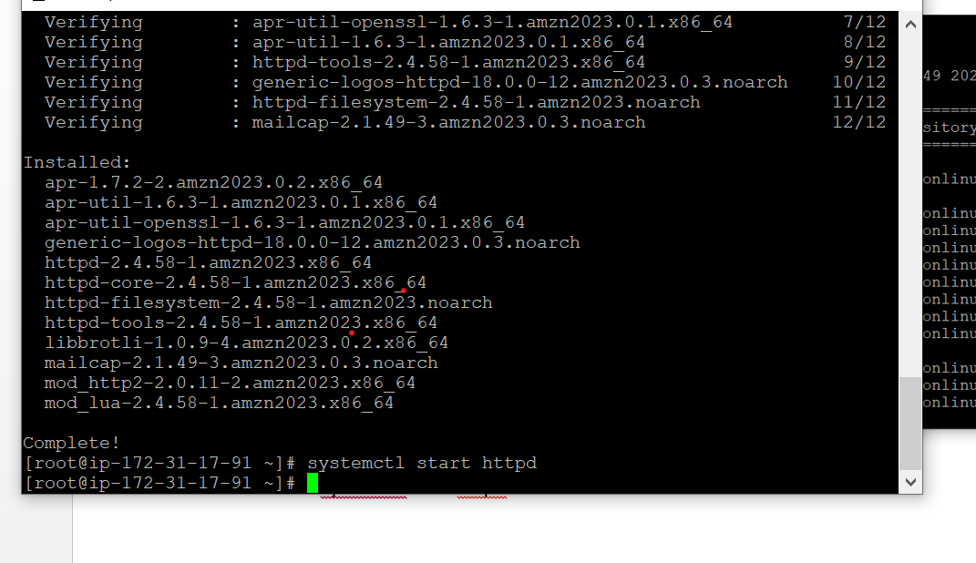

28. systemctl enable httpd:

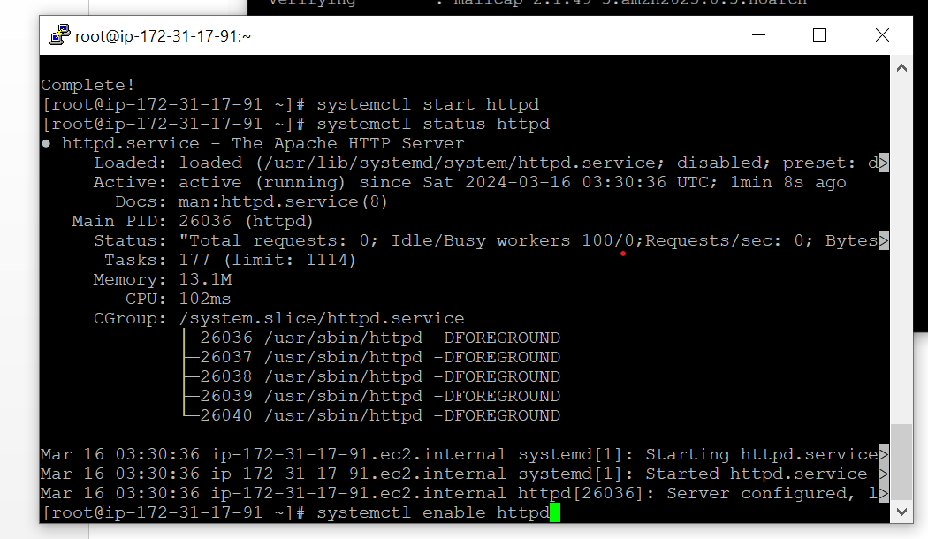

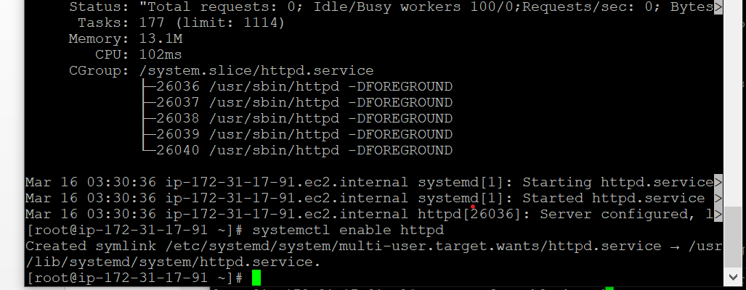

29. cd /var/www/html :

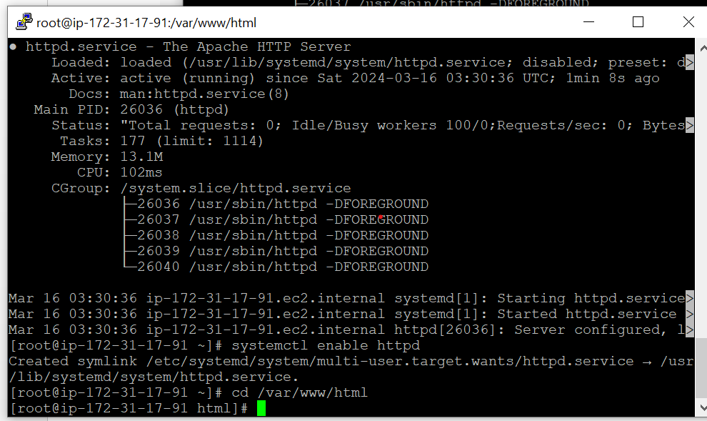

30 vi newfile.html :

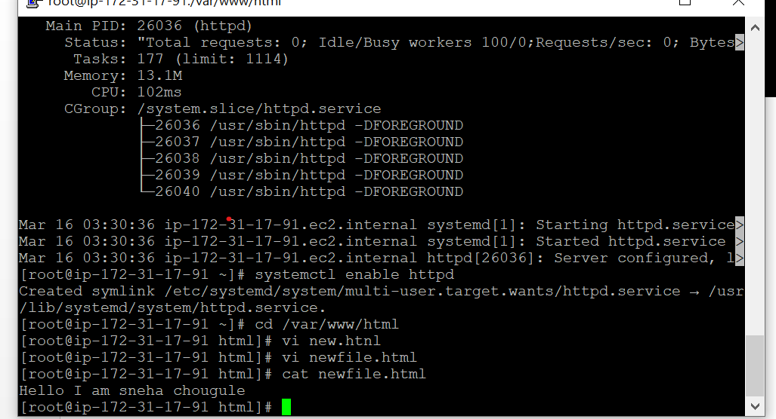

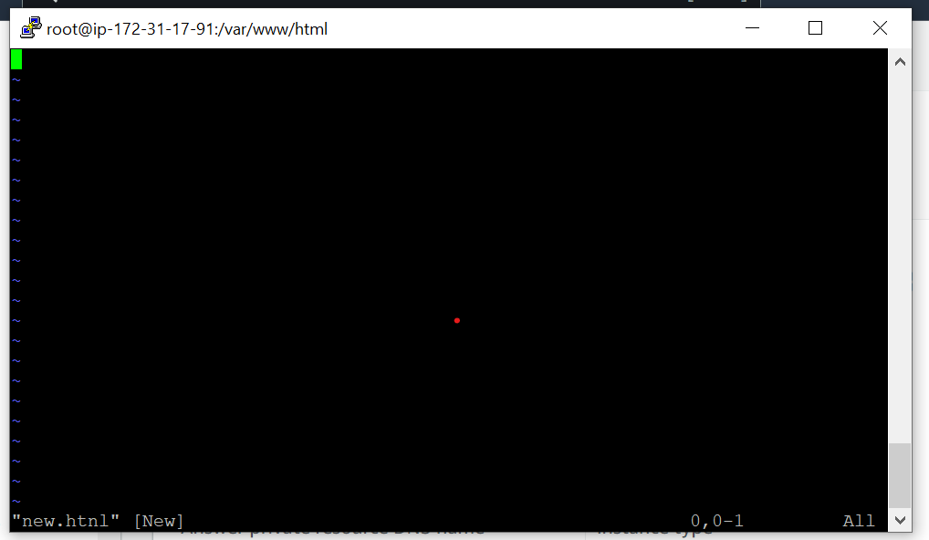

31: enter I to write and enter ese : wq to exit

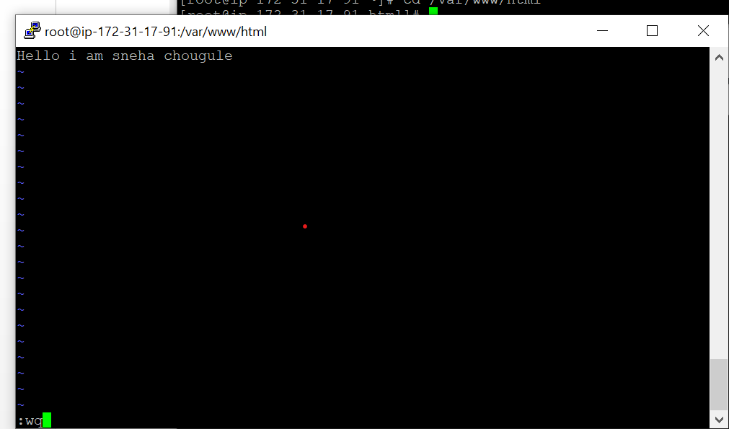

32 Then go to new tab and copy the instance ip address:

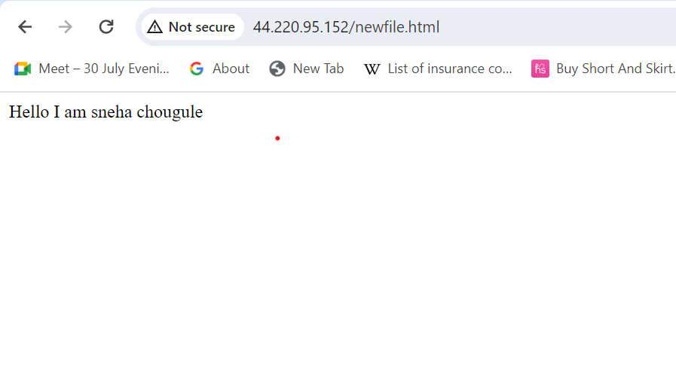

Cloud Q2

VPC:

1.Search vpc

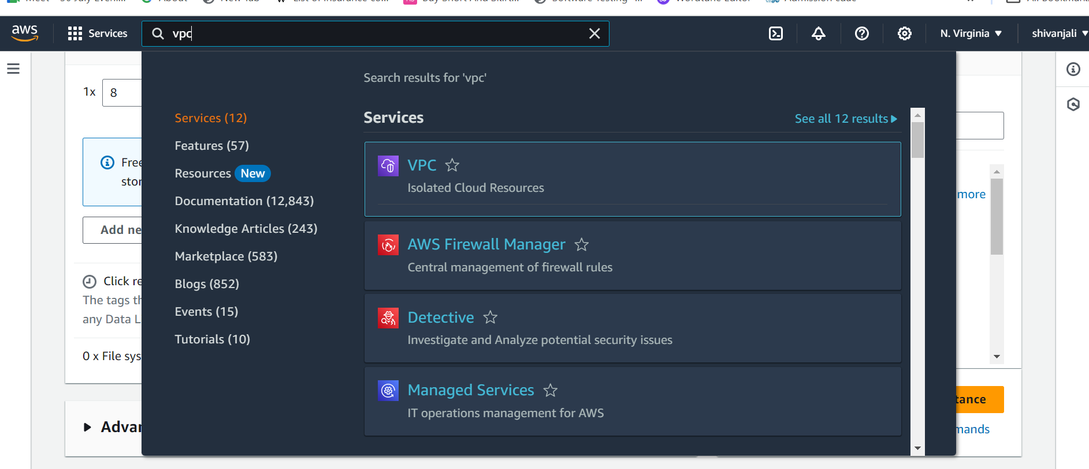

2.click on vpc then click on create vpc and select vpc only:

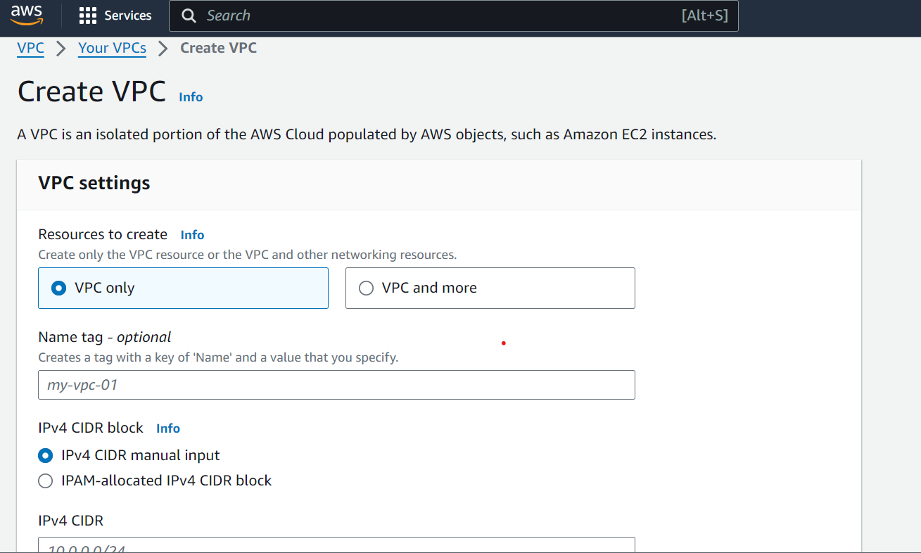

3.Give name to vpc:

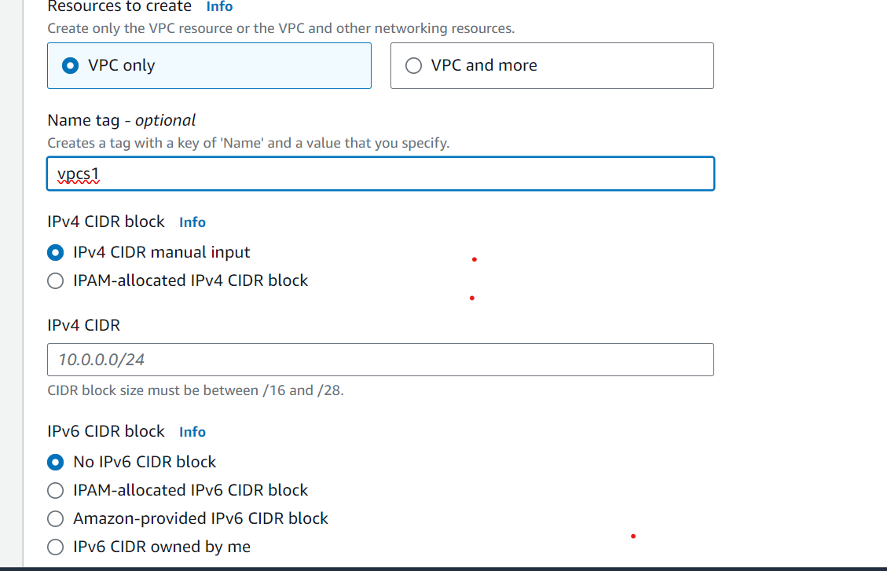

4.add ipv4 :

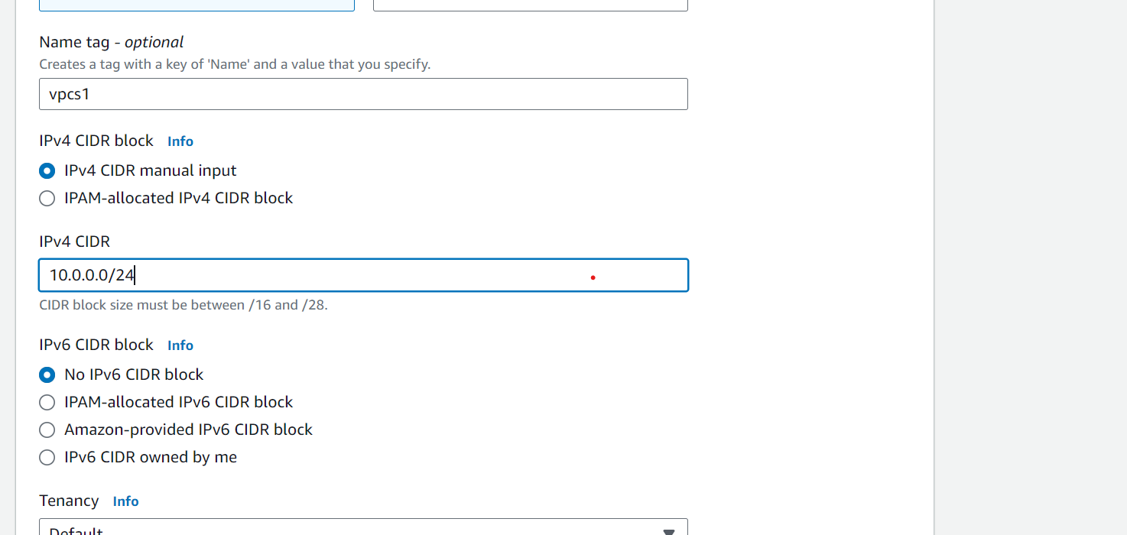

5.set all as it and click on create vpc

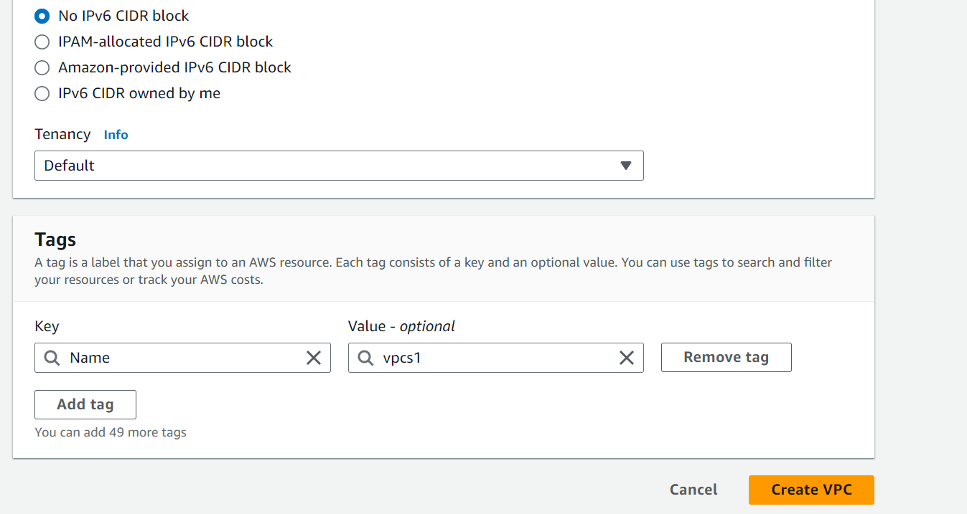

6.After complete create vpc then successfully vpc created window is display

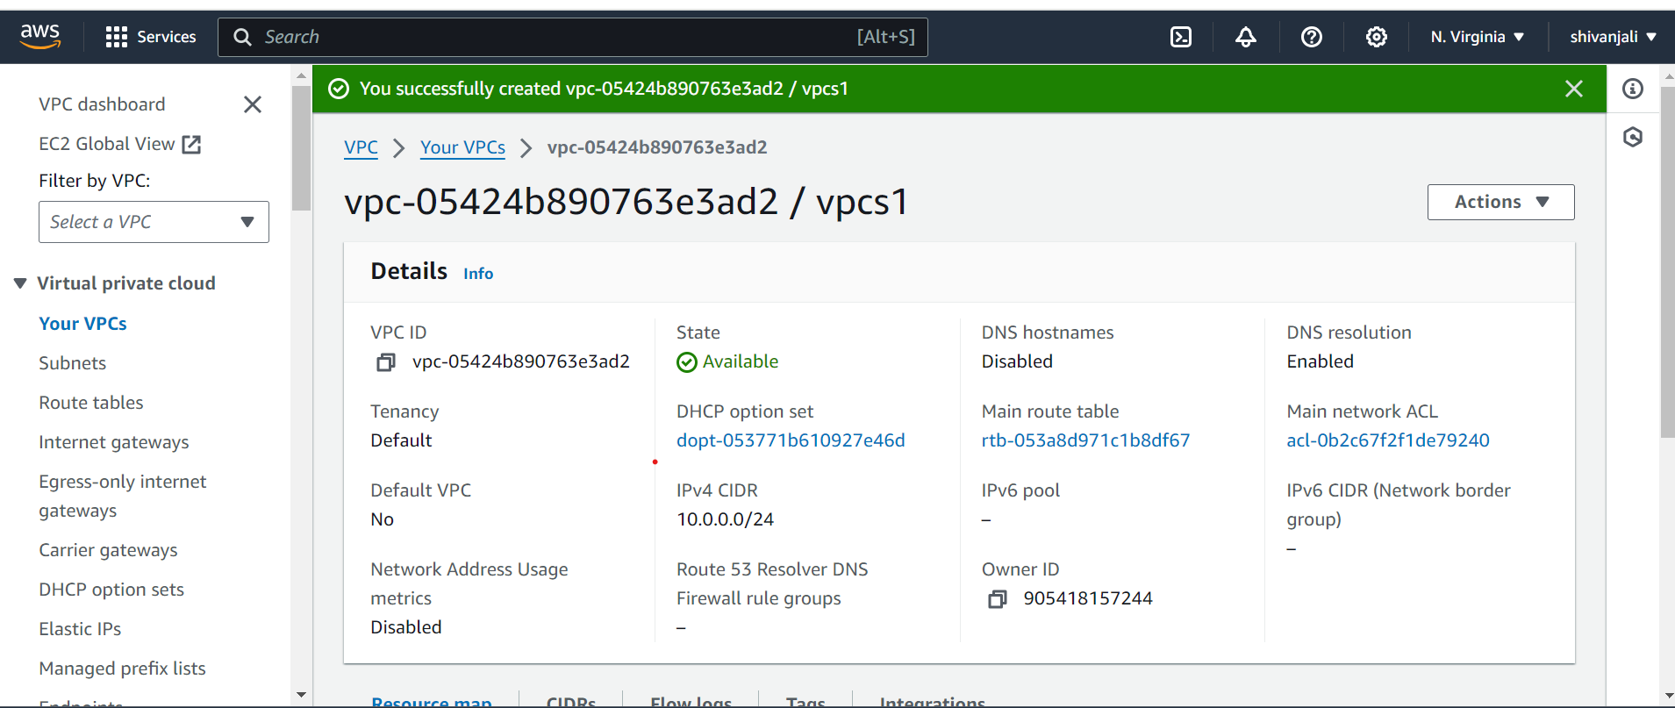

7.click on the subnets

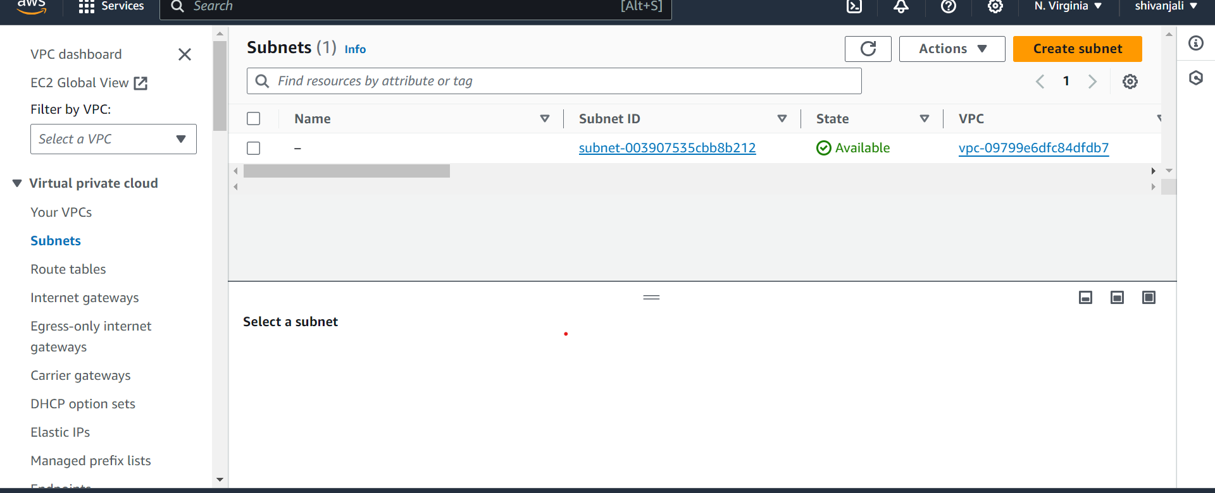

8.click on create subnet and select vpc

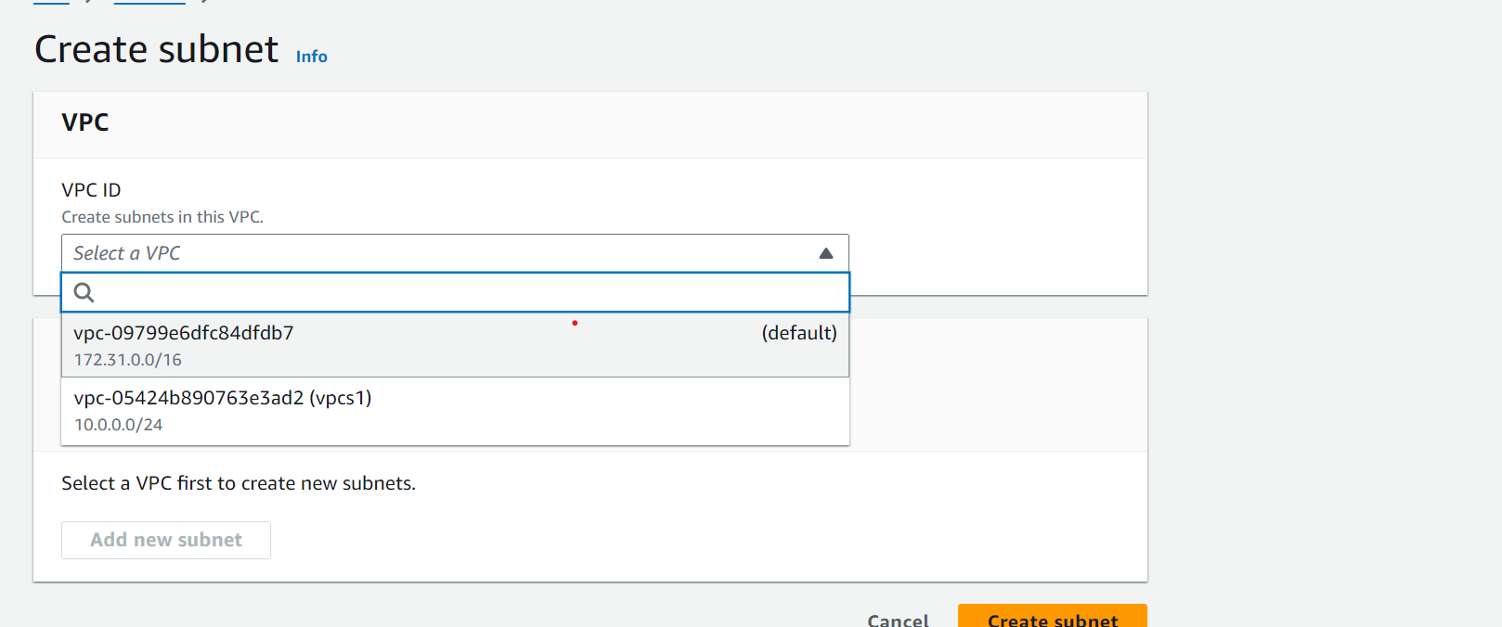

9.give subnet name

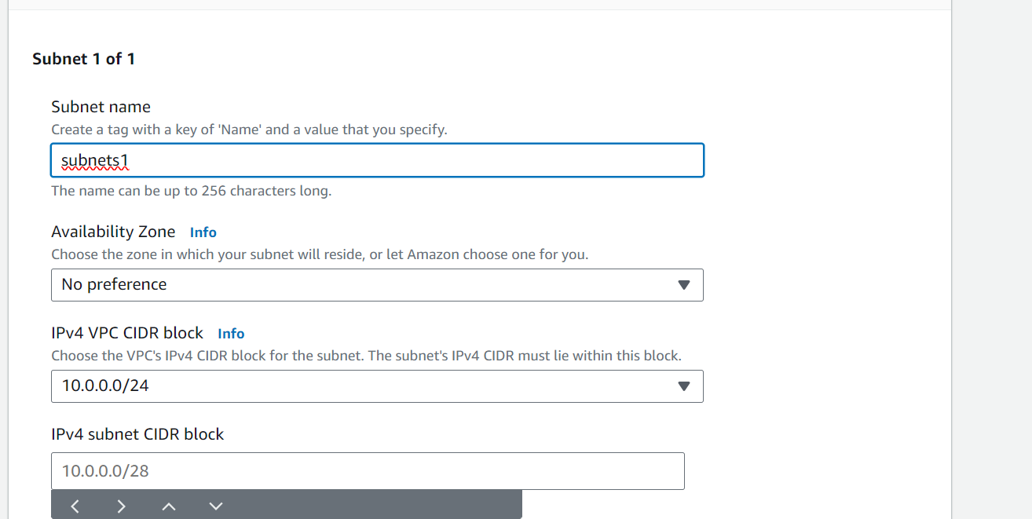

10 then enter ipv4 adddress subnet

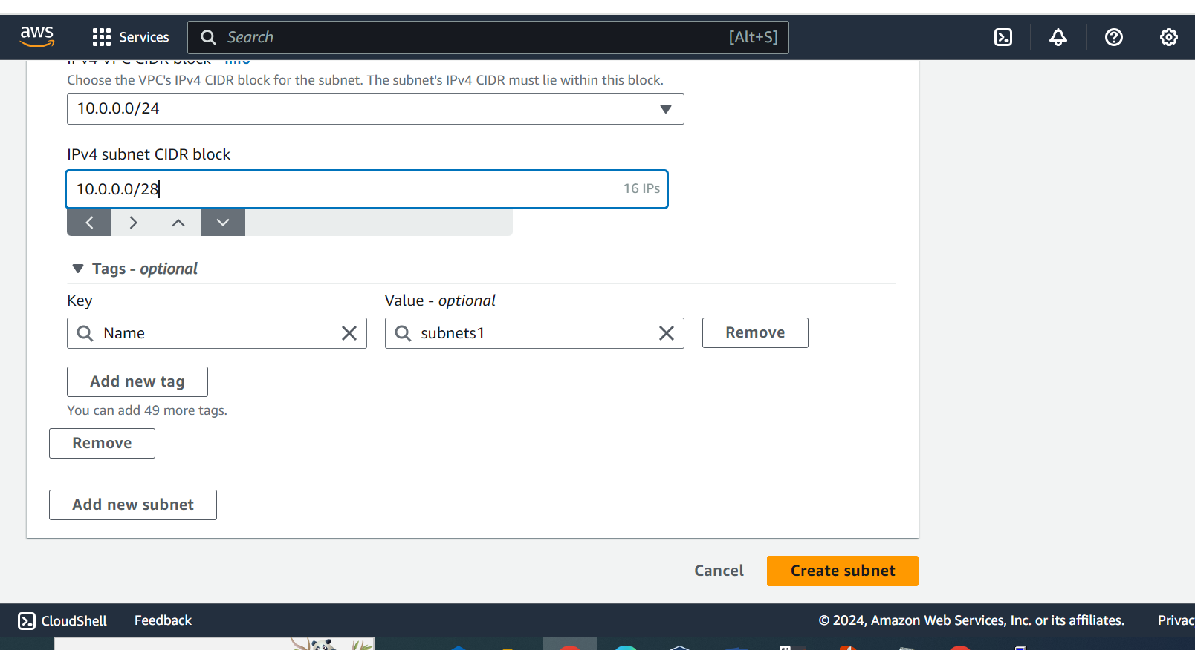

11. click on create subnet and then is show successfully created window

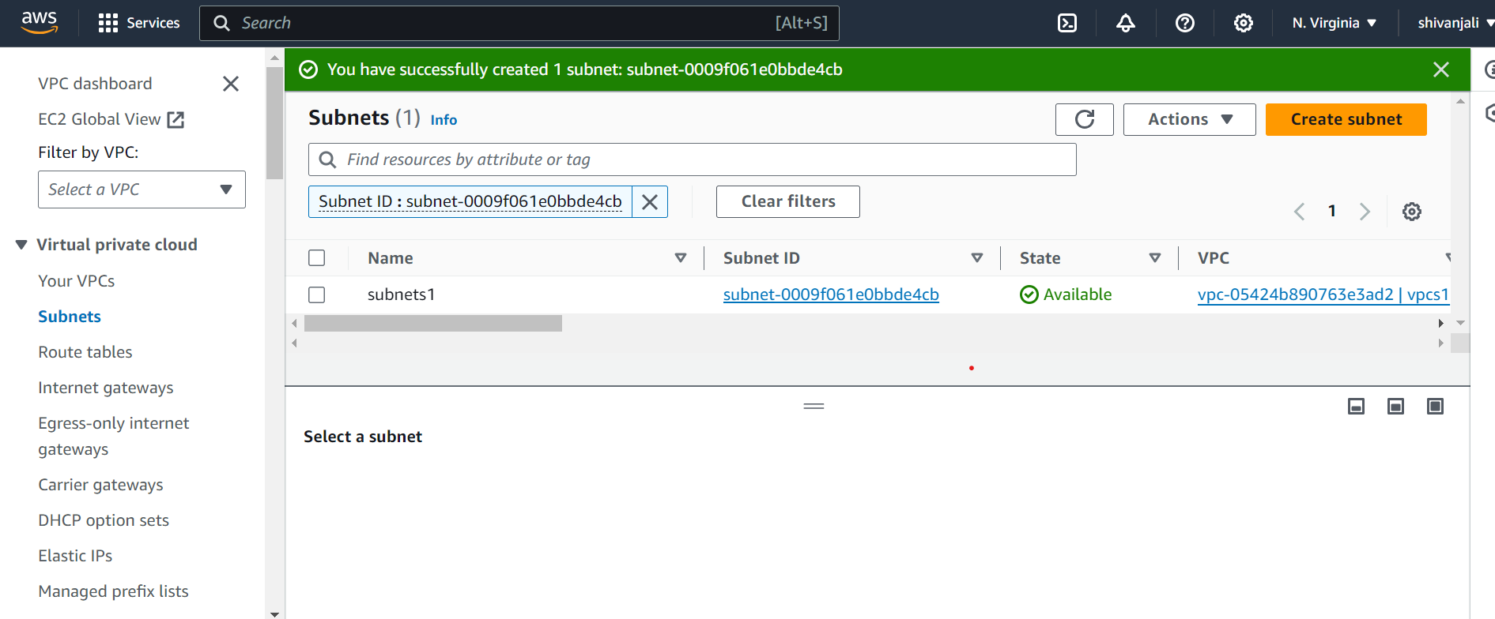

12 Again create another subnet

Click on subnet



13 click on create subnet and select vpc

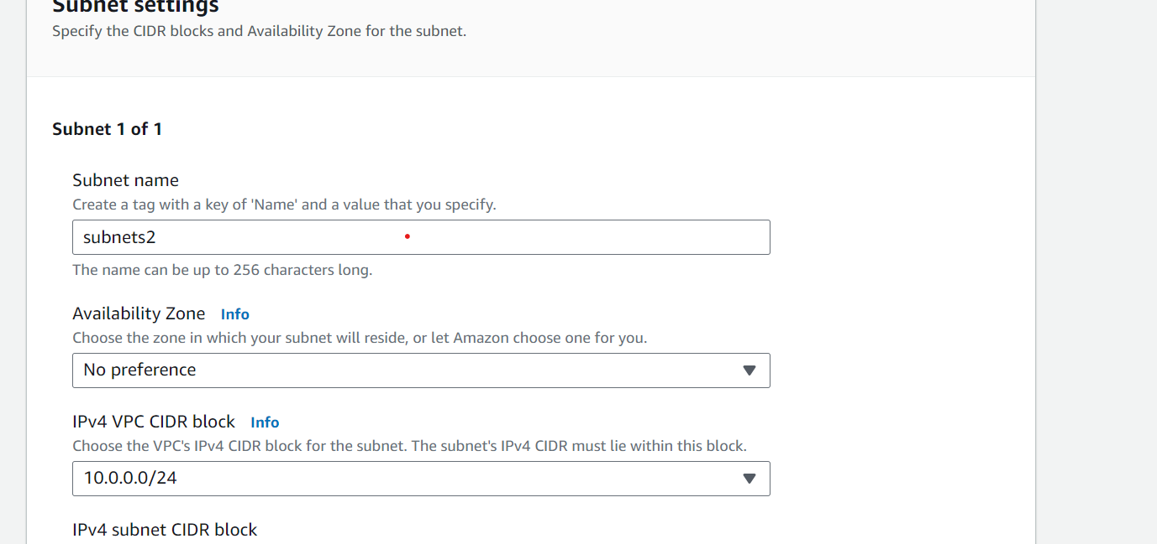

14.then enter ipv4 adddress subnet



15.

Linux Que 3

1 use mkdir command to create new directory

Syntax : mkdir directoryname



2 use mv command to rename the file

Syntax mv oldfilename newfilename

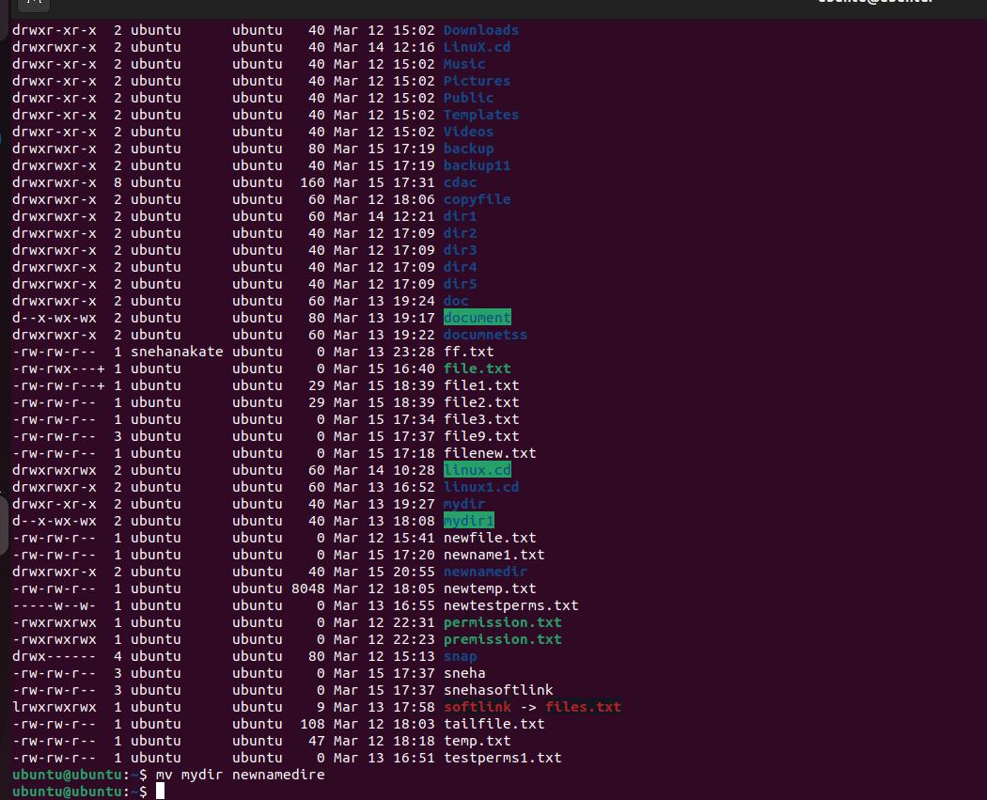

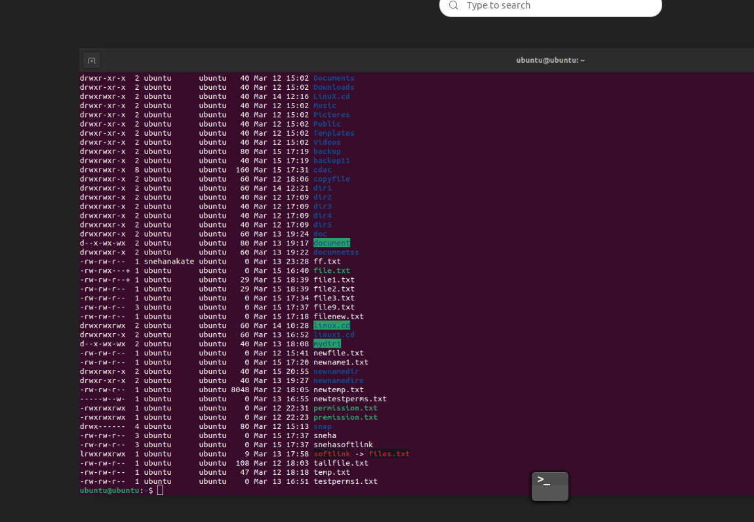

1. delete existing directory we use rmdir command

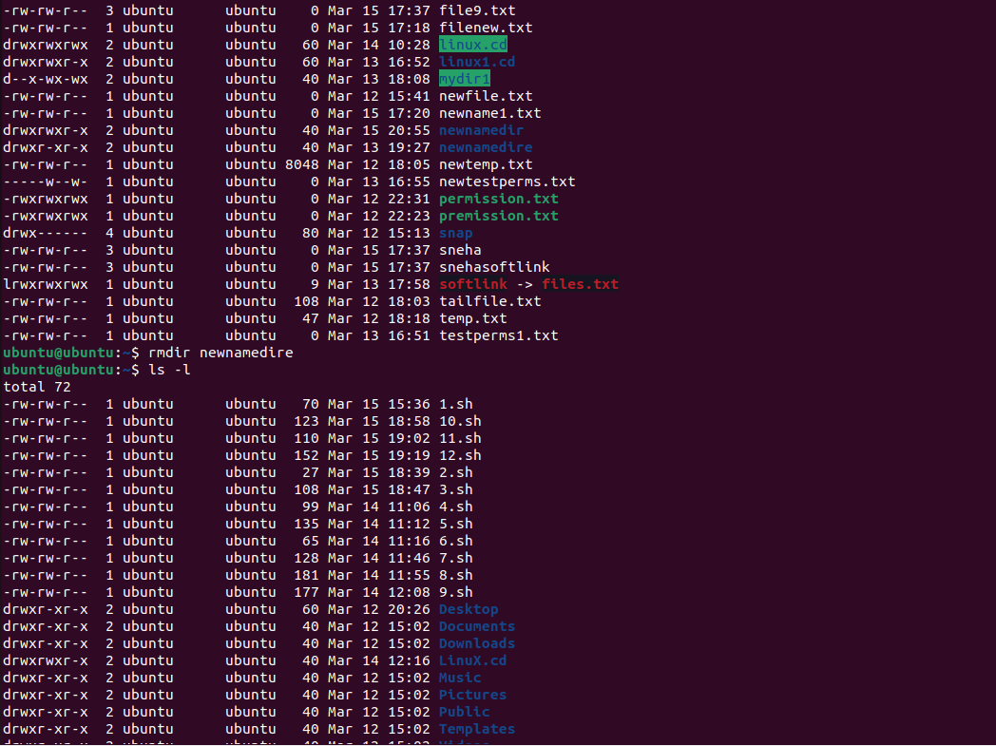

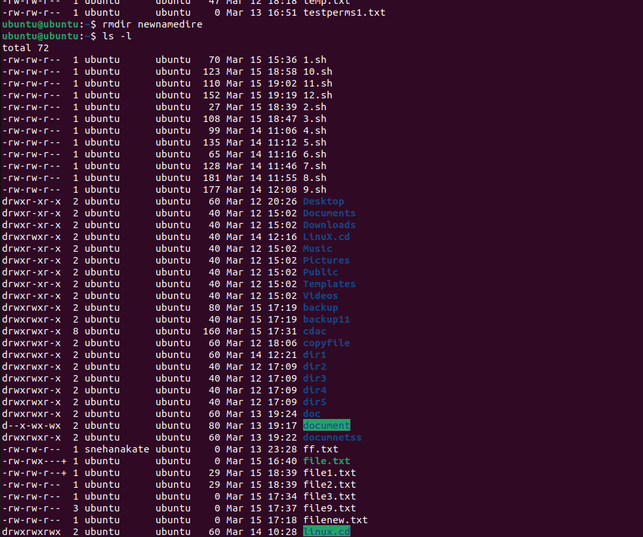

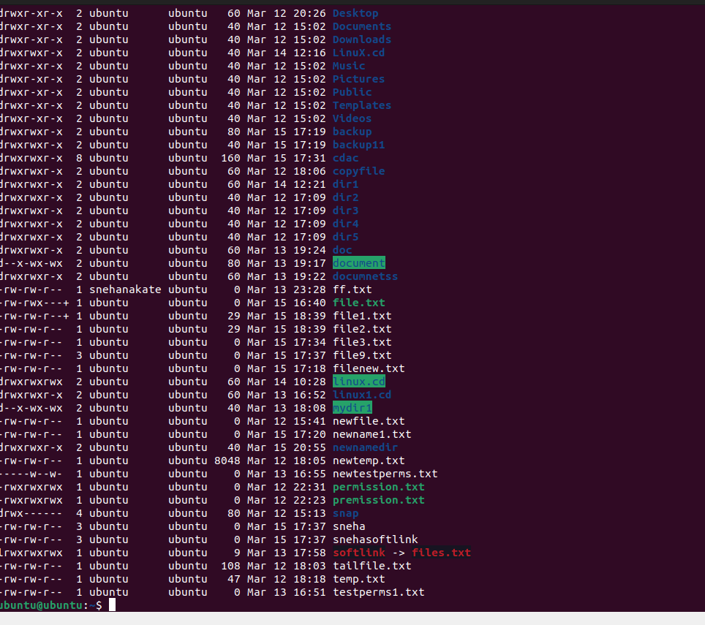

5 create file and hardlink we use touch command

